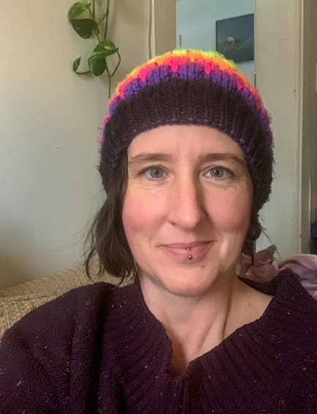
Vanessa Chambers, CYT 500, has been a student of yoga for 19 years. She began teaching the same way so many do; by having a driving desire to share what was so powerfully transformative in her own life with as many people as possible.

Vanessa began teaching in 2008, receiving her 200 hour certification. She then went on to complete 300 hours of advanced yoga teacher training, as well receiving certificates in kid’s yoga (Yoga for Young Ones), Yoga for Seniors, and Thai Yoga. She holds a B.A. in Holistic Health.

A pandemic induced hiatus from teaching has given Vanessa an opportunity to return in a thoughtful and methodical way. Vanessa views herself as a space holder. Her intention in sharing yoga is to assist a student to see the totality of who they are with less shame, defensiveness, and fear. This must come as a function of personal yoga practice, not as an insistence from the outside. Vanessa intends to suggest and guide. She does not have answers to what you “should” do. Those are within you. Her yoga classes will help you clear out the noise so you can hear what is right for you instead of defaulting to following what is outside.

