BIG Tree Search

For this BIG tree search Landis is looking for:

- NYS's BIGGEST tree. We are looking for the biggest overall single stem tree in New York State regardless of species.
- NYS's Champion trees.

A New York State champion is the biggest single stem tree of its kind in NYS. Remember, a champion apple tree will not be as big as a champion white oak will, but all are eligible as possible species champions! All winners will receive a CASH award, Landis membership, and Landis swag!

Single stem vs. multiple stems:
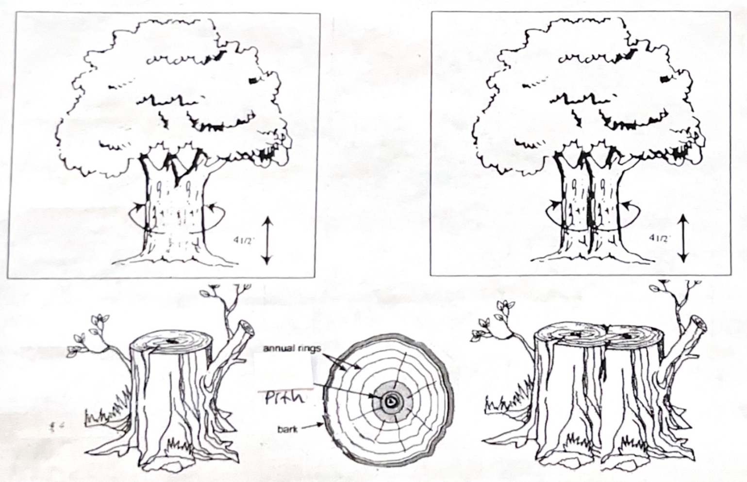

A single stem tree has one pith line at ground level, with concentric annual rings that surround that pith. How can we tell if we are measuring a single tree or
multiple trees where two or more trunks are fused? We use the pith test as our solution for this problem. Follow the central pith lines down the trunk(s):

- If the pith lines intersect clearly above ground level, we have one tree.
- If the pith lines at ground level are separated, we have more than one tree.

Join the fun - the search for the biggest trees is on!

You are invited to nominate a Big Tree Champion. Certificates and prizes will be awarded. The BIG Tree Search is FREE to enter - read on! The Big Tree Search is community-based and coordinated at Landis Arboretum.

How to Join the Search - It’s Easy!

Anyone can join the BIG Tree Search. Begin by looking in your neighborhood, in local parks, cemeteries, or other areas for large, living trees of any kind. Respect private landowners; ask permission before entering private property.

All species are eligible. Once you have located a possible champion. Try identifying its species. Please be as specific as possible on the nomination form.

Nominations should, at a minimum, include:
- Four digital images/
photographs capturing four quadrants (not necessarily based on cardinal direction).
- At least one “big picture” all-encompassing tree view.
- All pictures should include reference objects (person alongside, dbh/cbh tape wrapped around base at height measured, ruler).

Measuring Your Entry

Entries must include basic measurements of the tree - its height, circumference (the distance around the trunk) and average crown spread.

Trees qualify as BIG TREE Champions based on a point system devised by the National Register of BIG Trees. Scores are determined by adding the trunk circumference (in inches), plus the tree height (in feet), plus 1/4 of the average crown spread (in feet).

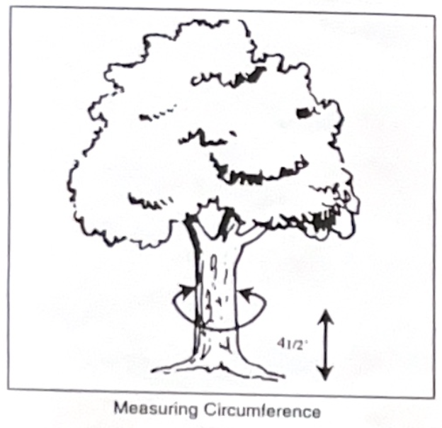
Circumference: first, using a tape of string measure (in feet and inches) the circumference or girth of the tree at a point 4 1/2 feet above the ground. Note: If the tree forks below 4 1/2 feet, measure the largest stem only.

Height: Next you will need to find the tree’s total height. This is simply the vertical distance between the topmost twig and a horizontal plane at the base of the tree.
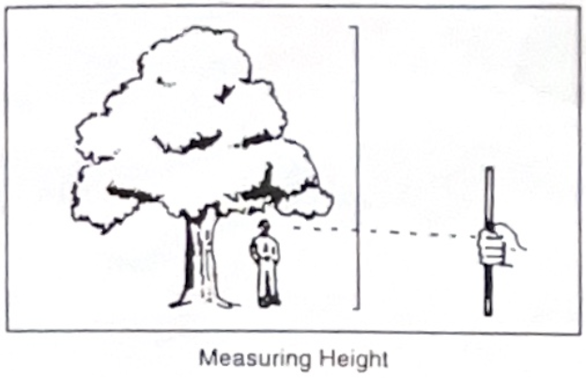
The most reliable measurements of the tree’s height are made with standard tree measuring tools such as a clinometer, Abney hand level, or a Forest Service hypsometer. However, the following are ways to estimate height:

- Compare the height of the tree to that of a nearby object. The peak of a two-story house is about 30 feet high.
- Have a friend stand at the base of the tree while you step back about 100 feet. Hold up a yardstick. Align the bottom of the yardstick with the base of the tree and your friend’s feet. Count the multiples of the friend’s height in feet by multiplying he count of the friend’s height.

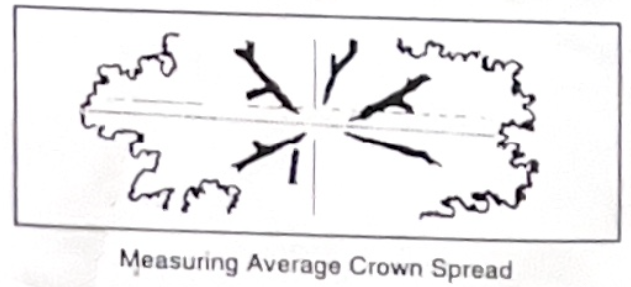
Average Crown Spread: You can estimate the average crown spread by measuring the distance under the outermost branches of the tree. Measure both the shortest and longest spread of the limbs, add these two measurements together and divide by two for the average width of the tree crown.

NOTE: In the case of two people submitting a form for the same tree,
we will only honor the first submission received.

Landis Arboretum wishes to thank Bill and Roberta Winsman
for their generous support of the 2023 Landis BIG Tree Search

Big Tree Search Nomination Form

Send to: Big Tree Search
Landis Arboretum
PO Box 186
Esperance, NY 12066. (or email to bigtreesearch@landisarboretum.org)

Phone: 518-875-6935 Email: bigtreesearch@landisarboretum.org

_________________________________________________________________________________
Tree Species (Common Name). Be as specific as possible.

_________________________________________________________________________________ Scientific Name (If known)

Tree Location (Address, or attach a written description)

_________________________________________________________________________________ Street Address

_________________________________________________________________________________ City/State/Zip

(Note: Be sure to include photos of your nominated tree.)

_________________________________________________________________________________ Name of Nominator

_________________________________________________________________________________ Street Address

_________________________________________________________________________________ City/State/Zip

_________________________________________________________________________________ Phone

_________________________________________________________________________________ Email

Has the owner given permission for the public to view the tree? ______ Yes ______ No

Tree dimensions:

Circumference: | Feet | Inches | Date Measured: |  | / | / 2023
Height: | Feet | Inches
Average Crown Spread | Feet | Inches

NOTEt In the case of two people submitting a form for the same tree,
we will only honor the first submission received.

Email to bigtreesearch@landisarboretum.org

Landis Arboretum wishes to thank Bill and Roberta Winsman
for their generous support of the 2023 Landis BIG Tree Search

